**Bingo small business owners’ app**

Submitted in partial fulfillment of the requirements

of the syllabus of

Android Apps Development Lab

in

Information Technology

by

JYOTI DEVADA 118A3010

DEVIN RAINA 118A3041

Under the Guidance of:

Ms. Bushra Shaikh



Department of Information Technology

SIES Graduate School of Technology

2021-22

**CERTIFICATE**

This is to certify that the project entitled **“**Bingo small business owners’ app**”** is a bonafide work of the following students, submitted to the University of Mumbai in partial fulfillment of the requirement of the syllabus of **Android Apps Development Lab** in **Information Technology.**

JYOTI DEVADA 118A3010

DEVIN RAINA 118A3041

Ms. Bushra Shaikh Dr. Lakshmi Sudha Dr. Atul N Kemkar

Internal Guide Head of Department Principal

**PROJECT REPORT APPROVAL**

This project report entitled ***Bingo small business owners’ app*** by following students is approved for the requirement of the syllabus of ***Android Apps Development Lab*** in ***Information Technology.***

JYOTI DEVADA 118A3010

DEVIN RAINA 118A3041

**Name of External Examiner: _____________________**

**Signature: _____________________**

**Name of Internal Examiner: _____________________**

**Signature: _____________________**

**Date:**

**Place:**

**DECLARATION**

I declare that this written submission represents my ideas in my own words and where others’ ideas or words have been included, I have adequately cited and referenced the original sources. I also declare that I have adhered to all principles of academic honesty and integrity and have not misrepresented or fabricated or falsified any idea/data/fact/source in my submission. I understand that any violation of the above will be cause for disciplinary action by the Institute and can also evoke penal action from the sources which have thus not been properly cited or from whom proper permission has not been taken when needed.

JYOTI DEVADA 118A3010 ______________

DEVIN RAINA 118A3041 ______________

Signature

Date:

**ACKNOWLEDGEMENT**

It gives us immense pleasure to thank Dr. Atul N Kemkar, our Principal, for extending his support to carry out and develop the project. We also thank our Head of Department Dr. Lakshmi Sudha for her support in completing the project. We wish to express our deep sense of gratitude and thank to our Internal Guide, Ms. Bushra Shaikh for her guidance, help and useful suggestions, which helped in completing our project work in time.

We would like to thank the entire faculty of Information Technology Department for their valuable ideas and timely assistance in this project, last but not least, we would like to thank our non-teaching staff members of our college for their support, in facilitating timely completion of this project.

**Project Team**

JYOTI DEVADA

DEVIN RAINA

**ABSTRACT**

After the pandemic hit the world, many employees, business owners, entrepreneurs suffered great losses. Many shifted their businesses completely to online mediums and shifting the physical shops to virtual setups. Technology has become a part of many people's lives in this age. However, many people in these changing times have still not been exposed to the modern advances. These people may either be lacking the resources or the knowledge\ education or the grasping power to learn due to old age. This steals from them the opportunity to continue their business and hence obstructing their income in these testing times. The solution to this is providing them user friendly platforms. Hence, this Android application is to provide such small businesses a platform similar to the applications people are accustomed to in their everyday life.  The application will enable the vendors to create a simple profile like everyday social media app to interact with their consumers and sell their products easily hassle free.

**Contents**

|  |  |  |
| --- | --- | --- |
|  |  | **Page No.** |
| **Chapter 1** | **Introduction** | 8 |
| **Chapter 2** | **Survey of Existing Apps** | 9 |
| **Chapter 3** | **Report on Present Investigation** | 10 |
|  | 3.1 Problem Statement | **10** |
|  | 3.2 Source of Problem Statement | **10** |
| **Chapter 4** | **Design and Implementation of Android Apps Components** | 11-18 |
|  | 4.1 Layouts | **11** |
|  | 4.2 Intents | **11** |
|  | 4.3 Activity | **11-16** |
|  | 4.4 Firebase | **16** |
|  | 4.5 Camera | **16** |
|  | 4.6 Location API | **17** |
|  | 4.7 Generate APK file | **17** |
| **Chapter 5** | **Report on Proposed System and its Implementation** | 19-21 |
|  | 5.1 Block Diagram | **19** |
|  | 5.2 Flowchart | **20** |
|  | 5.3 Hardware | **21** |
| **Chapter 6** | **Results and Discussions** | 22-27 |
|  | 6.1 Summary of Screenshots with Navigational Flow |  |
| **Chapter 7** | **Conclusions** | 28 |
| **References** |  | 29 |

**Introduction**

Providing an opportunity to everyone for equal reach and exposure as the giant companies is the aim of this project. The project reflects on daily lives on small business owners, household entrepreneurs and artists that may not be qualified to understand the complexities of a seller site. However, social media is a part of everyone’s life due to the popularity and the easy-to-understand interface. Hence, we’ve created the application in a way to replicate the most popular social media site’s interface that appeals the small business owners and give them confidence to restart or start their business on an online platform and resurrect their source of income. The application offers options to upload pictures of their products, suggests their profile to consumers, enables them to chat with their potential consumers. It also enables the consumer to review the shop’s physical location, making the businesses visible to people in their locality.

**Survey on Existing Apps**

1. **Meesho:**

It’s an app for small business owners and resellers . The buyer can buy any item sold by the seller. The buyer can either keep it or re-sell it from the app and earn profits from it .

Features :

* Anyone can sell
* Delivery is provided
* Feature that shows profit margin of your re-sell.

1. **Go Daddy.com :**

It is a website/app for people to register their small business and run their business from home /remote areas .

Features:

* Gives business a platform on global market
* Good security
* Discounts provided

1. **Shopify:**

Shopify is recently launched app for commoners to start their business from home .

Features

* Customer support
* Fraud analysis

**Report on Present Investigation**

**3.1) Problem Statement:**

In this application we are aiming to build an application for vendors .

The features are :

* Vendors and upload image on their feed
* Buyers can also make a profile and follow the vendors and view their profile
* A GPS module to show location

**3.2) Source of Problem Statement:**

Many shifted their businesses completely to online mediums and shifting the physical shops to virtual setups. Technology has become a part of many people's lives in this age. However, many people in these changing times have still not been exposed to the modern advances. These people may either be lacking the resources or the knowledge\ education or the grasping power to learn due to old age. This steals from them the opportunity to continue their business and hence obstructing their income in these testing times. The solution to this is providing them user friendly platforms. Hence, this Android application is to provide such small businesses a platform similar to the applications people are accustomed to in their everyday life

**Design and Implementation of Android Apps Components**

**4.1) Layouts**

A view group that displays child views in relative positions is RelativeLayout. Each view's position can be specified relative to sibling elements or relative to the parent RelativeLayout area. It eliminates nested view groups and keeps layout hierarchy flat, a RelativeLayout is a very powerful tool for designing a user interface. We may be able to replace several nested LinearLayout groups with a single RelativeLayout.

For our application we used grid layout, linear layout and relative layout for customization of inner components wherever needed.

**4.2) Intents**

An Intent is an object that can be used to request a specific action from another app component. An Activity in an app represents a single screen. By passing an Intent to startActivity, you can start a new instance of an Activity (). The Intent describes the activity that is about to begin and contains any necessary data.

We have used Intent to go from one page to another. The external class to be invoked is provided by intent. Example is provided below:

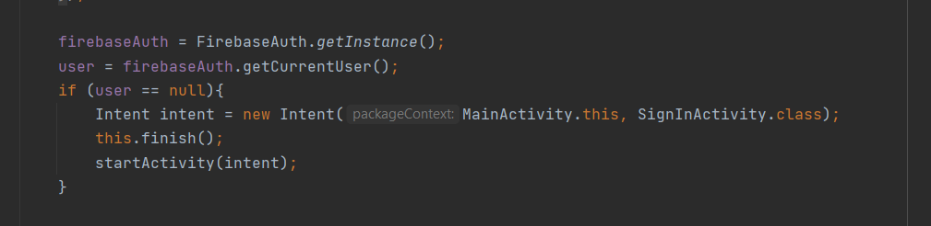

**4.3) Activity**

The Activity class is an essential component of an Android app, and how activities are launched and assembled is a key component of the platform's application model. It is built-in with the platform's main programming paradigm. Each step in the lifecycle of an Android app is initiated by a specific method and a defined callback method.

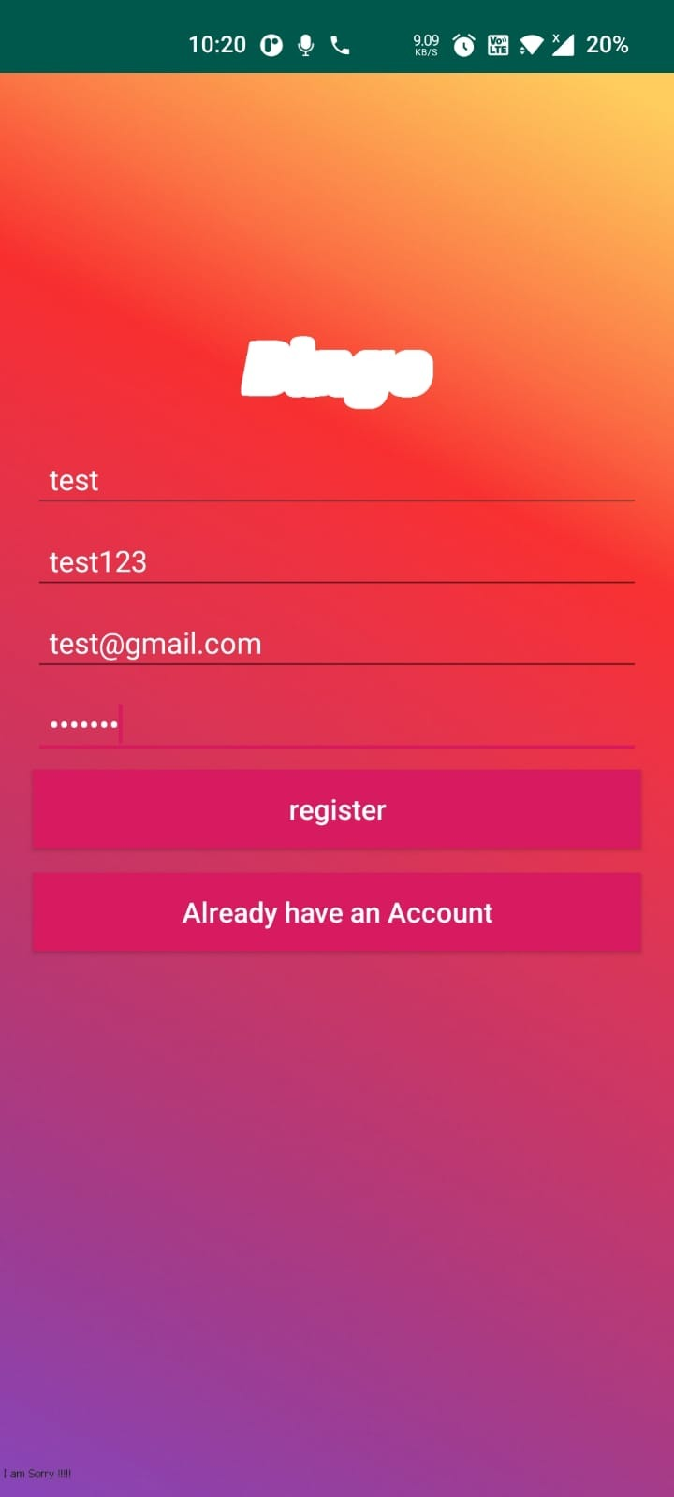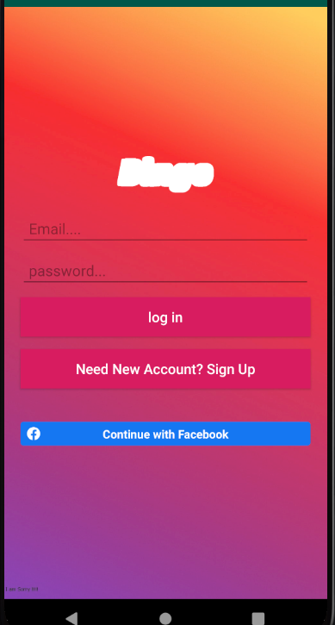

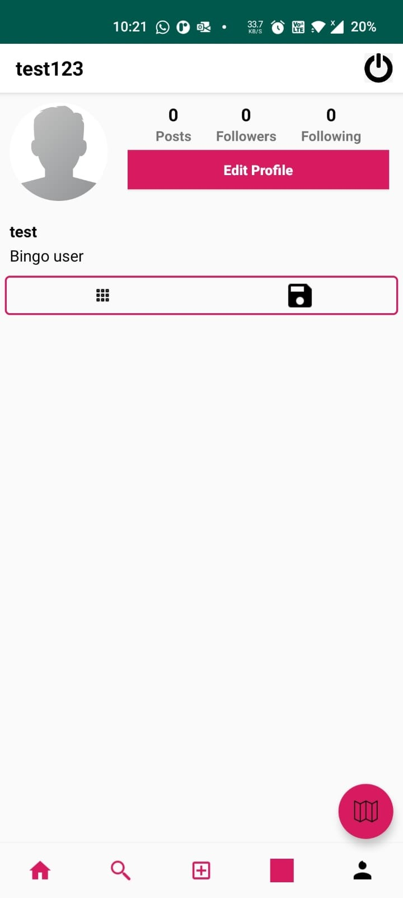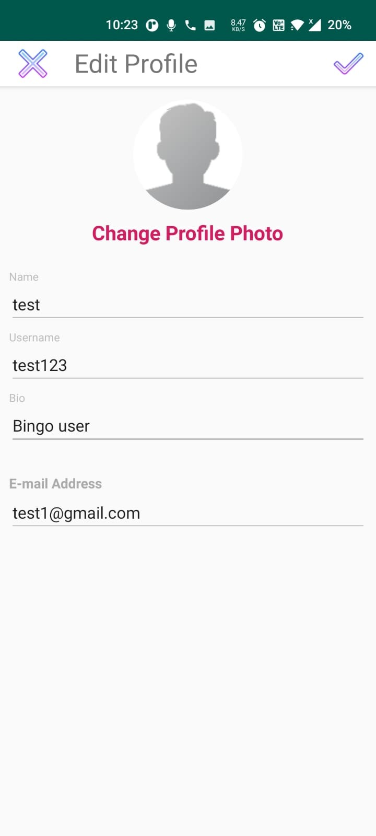

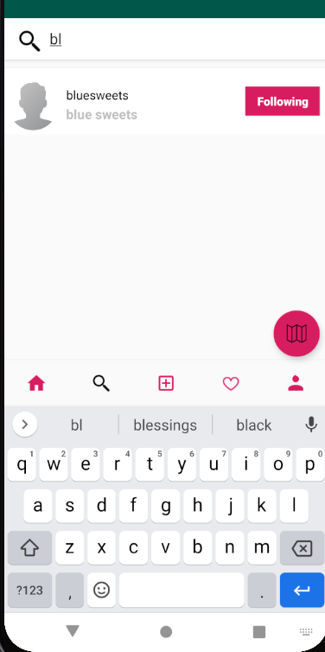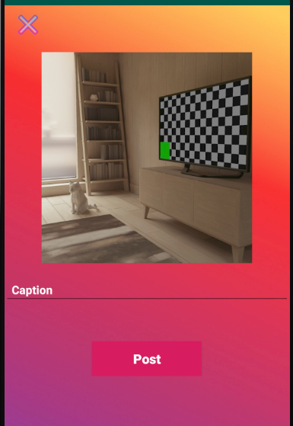

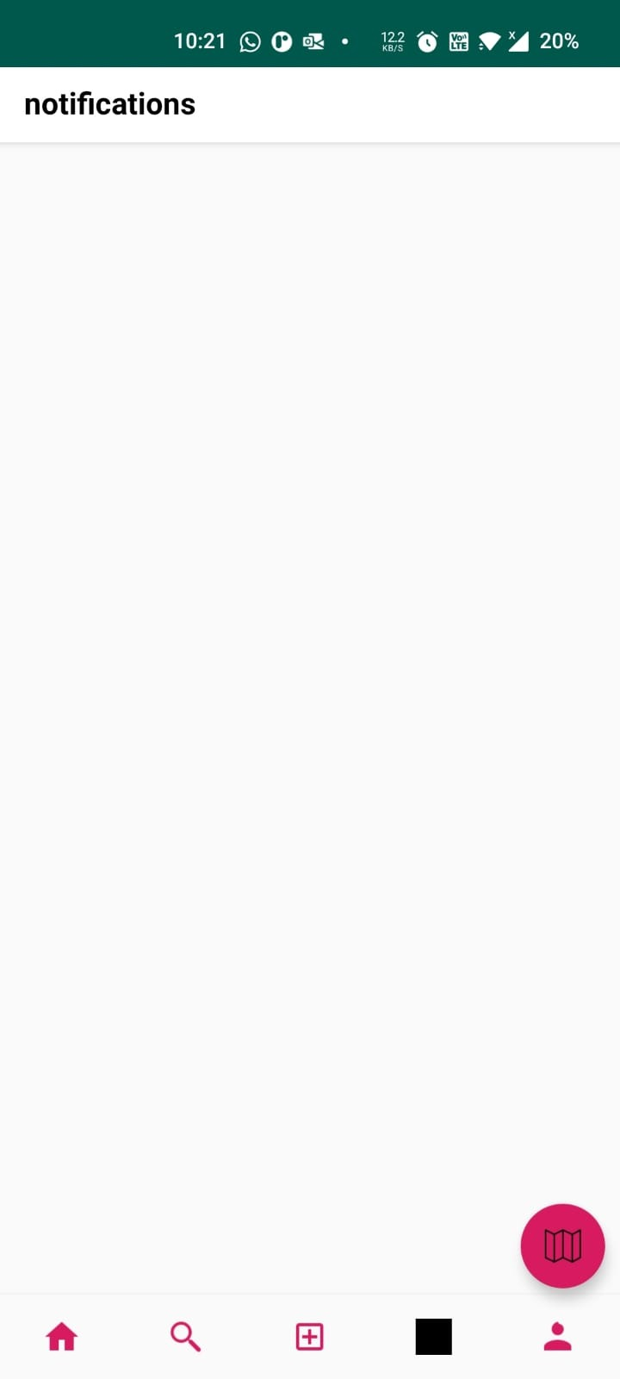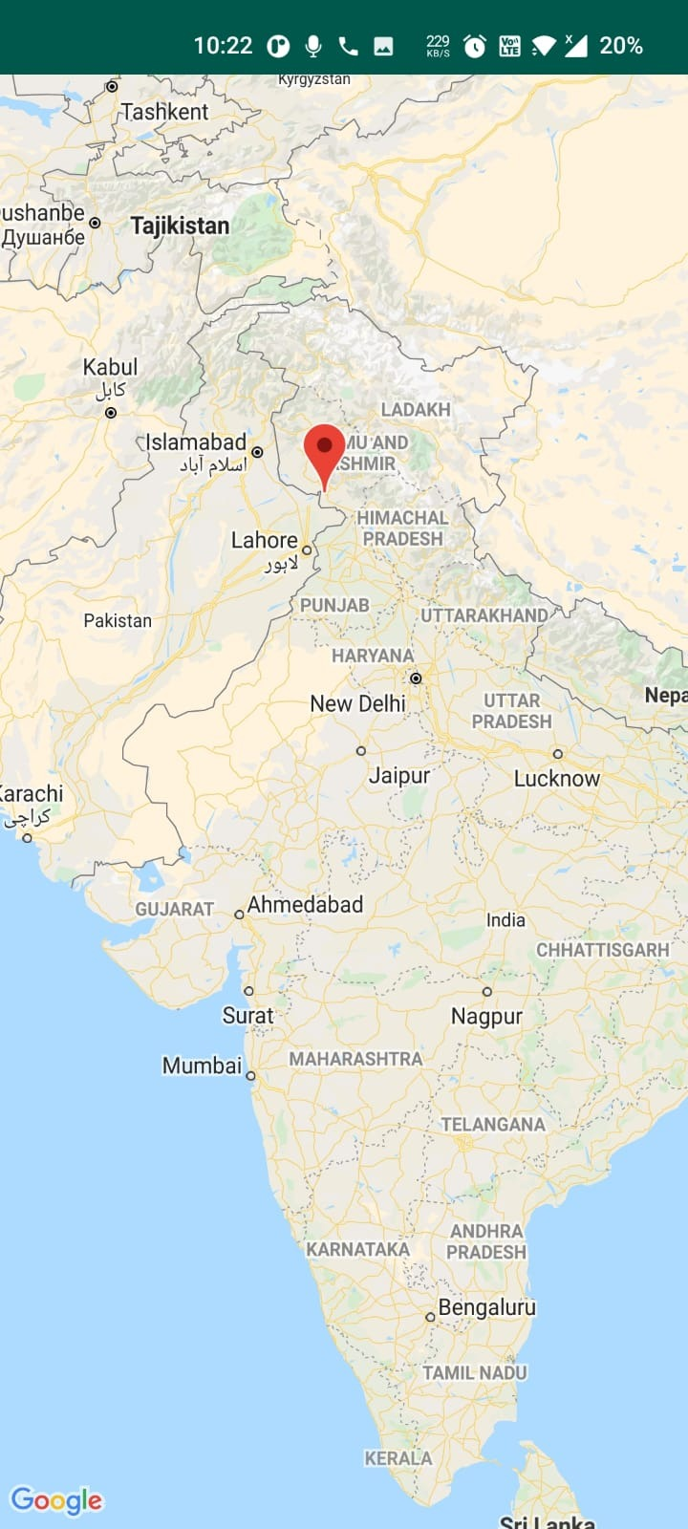

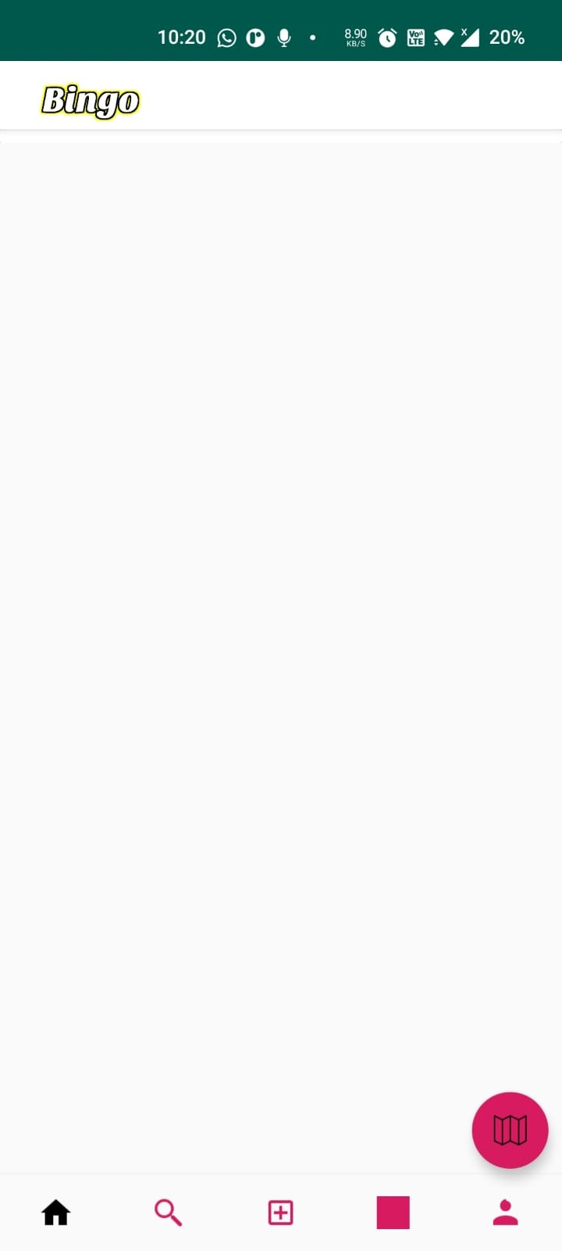

**4.4) Database**

Google Firebase is a product that allows developers to easily build, manage, and grow their apps. It enables developers to create apps more quickly and securely. Because no programming is required on the firebase side, its features can be used more efficiently. It offers services for Android, iOS, the web, and Unity. It offers cloud storage. It employs NoSQL as a database for data storage.

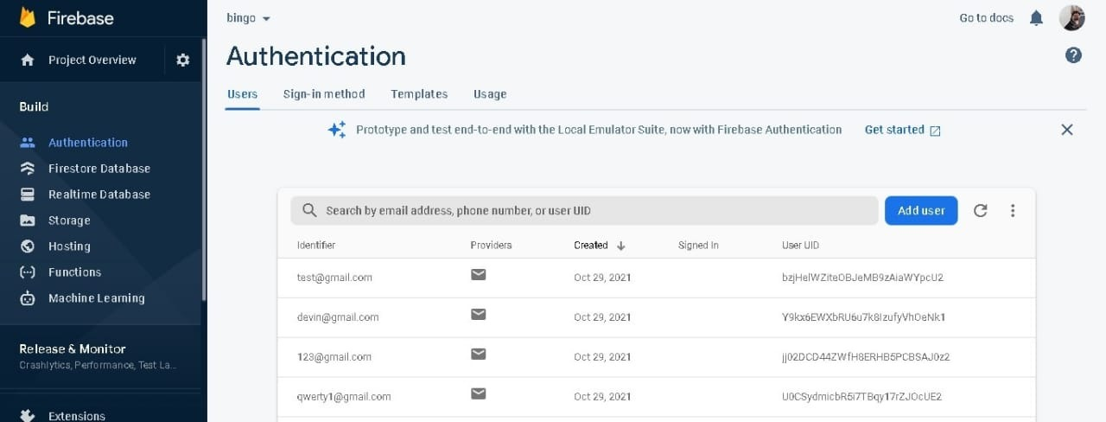

**4.5) Camera**

We have used the camera here to click and upload images on the profile.



**4.6) Location API**

Location awareness is one of the distinguishing characteristics of mobile applications. Mobile users carry their devices everywhere, and incorporating location awareness into your app provides users with a more contextual experience. With automated location tracking, wrong-side-of-the-road detection, geofencing, and activity recognition, the location APIs available in Google Play services make it easy to add location awareness to you

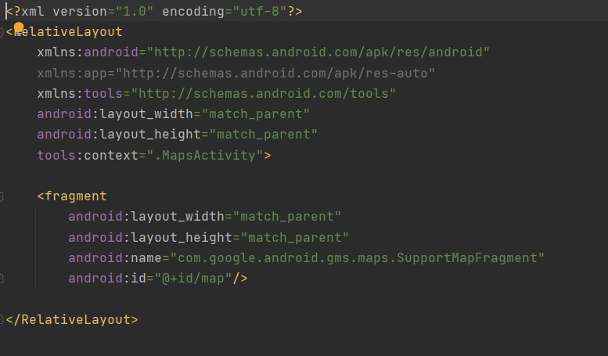

**4.10) Generate APK**

Before an APK can be installed or updated on a device, it must be digitally signed with a certificate. When using Android App Bundles, you must sign your app bundle with an upload key before uploading it to the Play Console, and Play App Signing handles the rest. You must manually sign your APKs for upload if you are distributing apps using APKs on the Play Store (created before August 2021) or other stores.

**Report on Proposed System and its Implementation**

**Block Diagram:**

As we can see that after the app is launched we are asked to login and if we are new users we are supposed to register . Once that is done , we can set up our profile, view location, post photos, add caption to it .

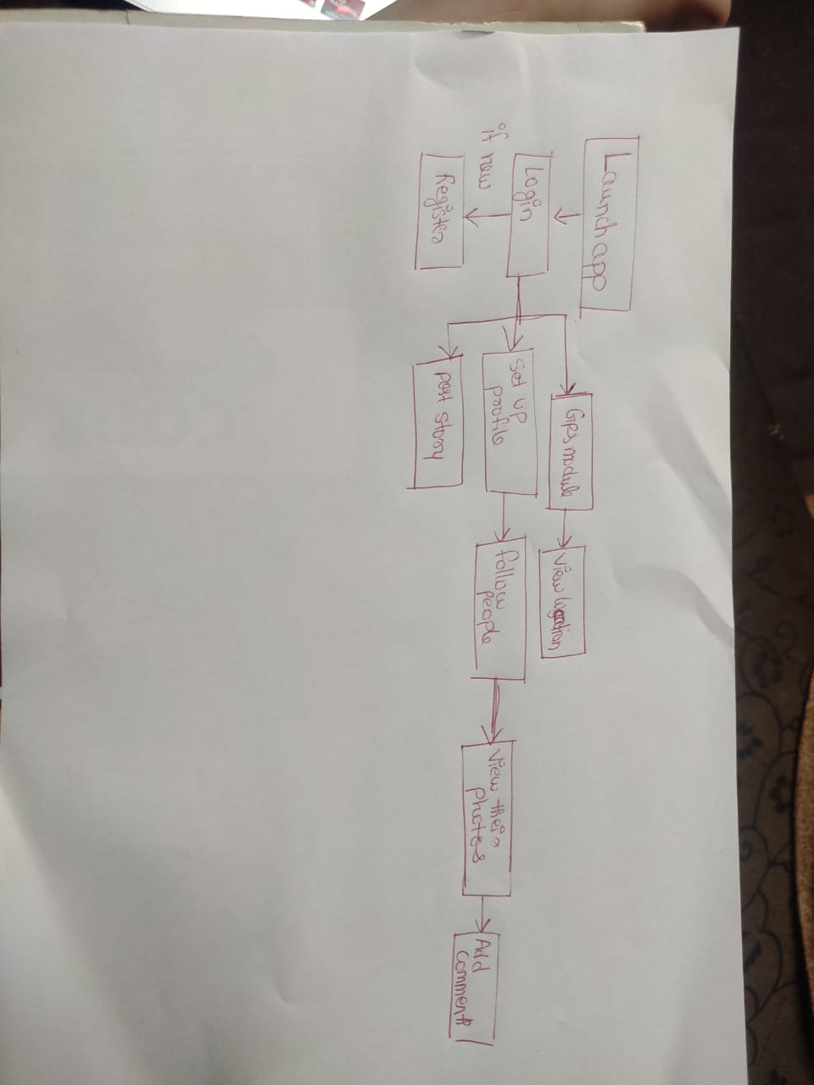

**Flowchart:**

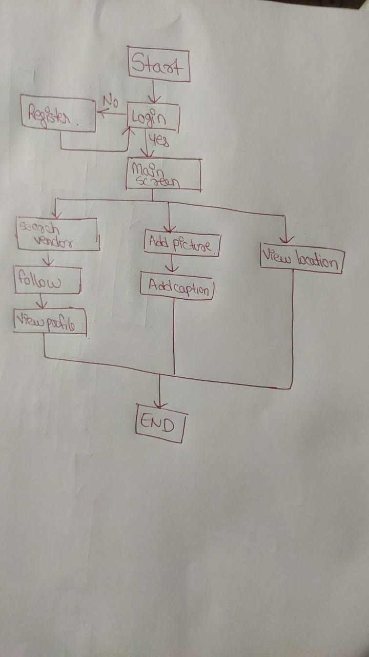

**Hardware –**

* Android Device
* Camera

**Software / External Libraries used with description –**

* Android studio
* GPS
* Internet

**Results and Discussions :**

**Module A: LOGIN REGISTRATION**

We have created login Registration to which we added authentication using firebase. We visited the Firebase console and under the authentication tab, enabled email/pass authentication. We have two xml files one being activity_registration.xml and other activity_login.xml. The registration activity has four EditTexts, two TextView,an imageView and a Button. All these views are contained in a Linear Layout with vertical orientation which is in turn under Relative Layout. EditTexts are used to get name, email,mobile number and password from the user. Button is used for signup purposes after filling the details.



**Module B: Searching and following vendors**

In this app, we can search the vendor and follow them which allows use to view their feed .



**Module C:  Notification**

In this module ,the user receive notification about his activity.



**Module C:  Camera**

The Android framework supports various cameras and camera features available on devices, allowing one to capture images and videos in your applications. We request permissions to use a device camera using the below:

<uses-permission android:name="android.permission.CAMERA" />



**Module D: Google Map**

We need to generate a Google Map API key. We need to implement some interfaces and callback methods in order to display the user's current location. Callback methods are OnMapRreadyCallback, LocationListener, GoogleApiClient.ConnectionCallbacks and GoogleApiClient.OnConnectionFailedListener. We have also included a runtime permission Manifest.permission.ACCESS FINE LOCATION to the above Maps.java file, which requests access to the device's location. The runtime permission is checked using the checkSelfPermission() method, and the PackageManager is returned. PackageManager.PERMISSION GRANTED or PackageManager.PERMISSION DENIED If permission is granted, the app will continue to operate.



**Module E : Profile and home page**

Here you can edit your profile and also view your post. In Home activity the user can view the images of the vendors he is following



**Conclusion**

Thus we have created an application with login /register and all the other required features .With this application the vendors can showcase their business easily and can interact with the buyers directly without any middleman .

Advantages of our app:-

1. Direct buyer ,seller interaction
2. Location visible
3. Can determine the interested customers with their feed interaction.
4. People can comment on the post

Disadvantages :-

1. Multiple photos cannot be uploaded in a single post.
2. No separate chatting place

Future scope:-

A chatting space for buyers and sellers to communicate directly, online payment portal can be added which will help the application to grow .

**References**

1. <https://firebase.google.com/docs/android/setup>
2. Firebase authentication, setup, storage, google-signin and notifications documentations.
3. https://www.youtube.com/watch?v=JAEldfC6b-c&list=PLj76U7gxVixSZIec8QSQCxHONZTZbQheG
4. Firebase Cloud Messaging Tutorials to implement the recent changes done in the FCM functions.